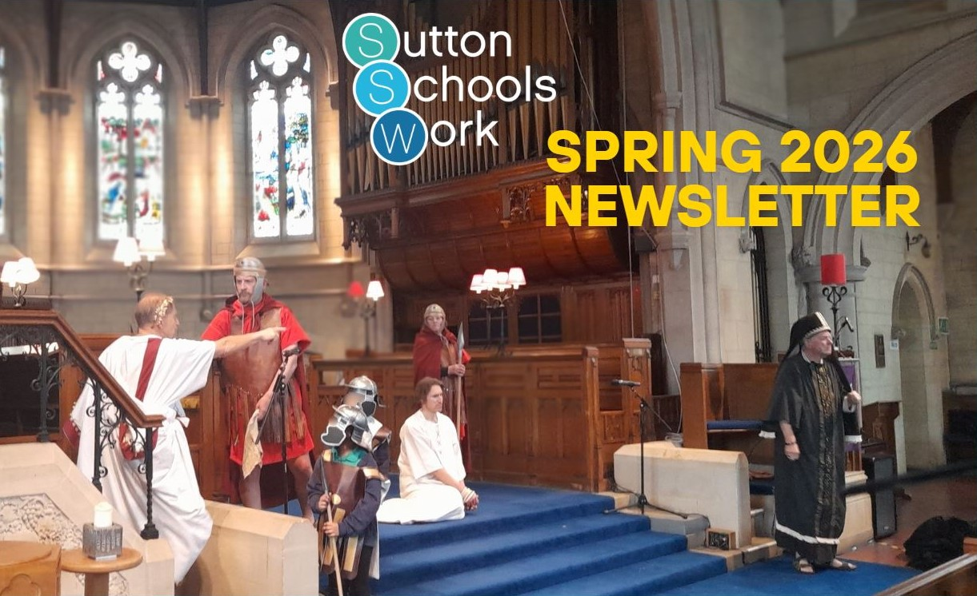



What a privilege to be a part of this wonderful, God-inspired organisation!
The first 3 months of activity of 2026 have been as busy as any we’ve known. Not only have we continued our regular engagements of CUs, lunchtime primary club, RE days and assemblies, we have delivered our largest ever Easter Experience! We’ve had the promise of yet another new CU materialise, given out even more New Testaments (950 in total), and spoken both at church gatherings, and with new leaders.
SSW can rightly be regarded as a loud voice within the schools of Sutton, proclaiming the truth of the risen Jesus with passion, clarity and integrity, and we are a welcome addition and presence in dozens of schools.
The name of Jesus is being spoken loudly and clearly in the hearing of thousands of children and young people on a regular basis, and as a result we are having encounters with those who have heard and are responding. From the question time at Easter Experience to the teacher who approaches a member at the end of a workshop to ask about faith, we have the joy of being part of the process of a heart being turned towards our loving Lord.
We are supported in prayer by hundreds of faithful believers across the borough, and are talked about around the country by those who hear of the work we are able to do. Committed volunteers join us in our work on a daily basis, enabling us to reach even more people with the Good News of the empty tomb.
What a privilege!
And yet, we face some difficult times ahead if we do not face up to a quite challenging fact – we do not receive enough money in donations to sustain our current activity. Despite reducing our staff numbers by 1 in the last year, we are likely to have to consider further reduction if current levels of giving remain the same.
Our organisation is sustained by prayer, volunteers, and by financial support. It is right that by far the majority of this funding should come directly from the faithful, and we need to find ways of encouraging more believers to see the incredible value of this work.
Therefore, after Easter we will be launching our ‘Giving of the 5000’ appeal. This will be accompanied by a video, and supporting literature, and will be designed in such a way that anyone can take part, no matter how much or little they feel they can contribute.
Please, could you support this appeal? Its ‘success’ will depend on the support given to it by our church leaders, so I would humbly ask that you encourage your own leadership to consider doing so. Making the work of SSW known to as many of the christians of Sutton as possible will, we are sure, enable even more to see its significance and importance, and will result in many responding to the request to give. Every minute spent in a school gives another series of opportunities to talk about Jesus, and we know from all the encounters we are having that these moments matter.
Look out for the launch, and talk about us in your fellowship!

And please pray!!!!
THANK YOU

SECONDARY UPDATE
I’ve delivered workshops to Year 7 at Oaks Park, Cheam High about Social Media and Self Image, and to year 7 at Sutton Grammar looking at the character of Abraham. Also, I presented assemblies at Overton Grange where I gave out hundreds of New Testaments.
Our CUs continue to see weekly attendance, with many new faces coming along, hearing others talk about their faith in and love for Jesus. One of my problems is that there are multiple groups, meeting every lunchtime around the borough, and there’s only one me! I am so grateful to the volunteers who help at these meetings, enabling me to visit groups and provide support and guidance where needed, and encouragement where the groups run themselves (what a blessing to be present at such groups, seeing genuine leadership skills being shown by 6th formers!)
Much of the second half of term was taken up by me participating in Easter Experience at 3 venues, and so there was reduced activity in my schools, but the new term looks to be busy.

Simon Ellingham
Director



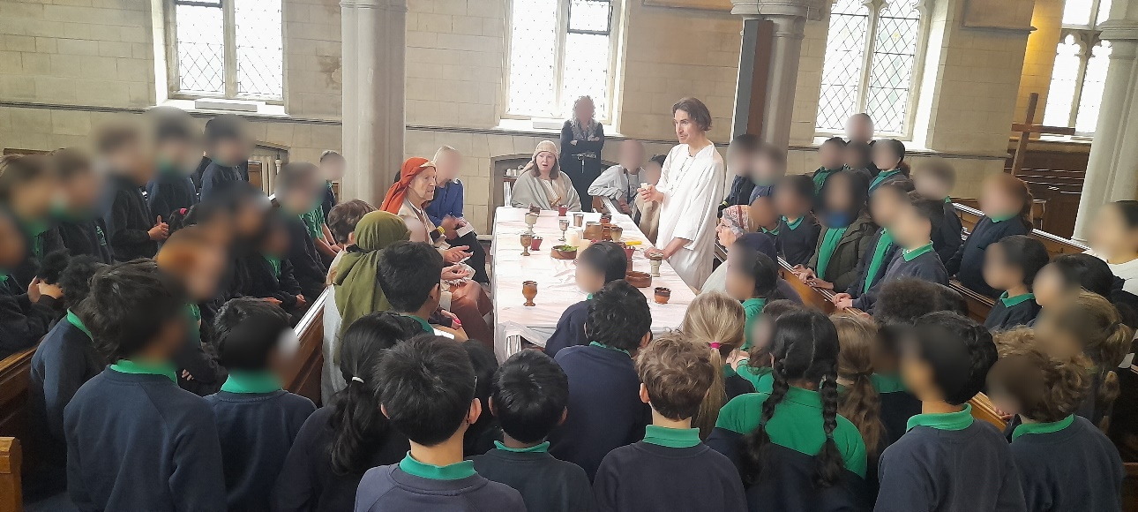



THANK YOU GOD:
- for an amazing half term!
- for health of the SSW team.
- for our INCREDIBLE volunteer team!
- for the AMAZING 4 weeks of Easter Experience this year!
PLEASE PRAY:
- that children and their families would visit churches this Easter Sunday.
- for the children and staff attending Easter Experience this year. May they know this as a TRUE story and be accepted.
- for the Y2/3s that we have run the CSI Easter Workshop with so far and for the remaining 4 schools we are running CSI Easter in after the Easter Break.
- for the Y3 Bible Explorers workshop & Y1 Creation Treasure Hunters Workshop we have booked in April.
- for protection over our volunteer team and good rest for them ahead of starting back up again after the Easter Break.

Thank you for your continued prayers!
Abby & Maisie

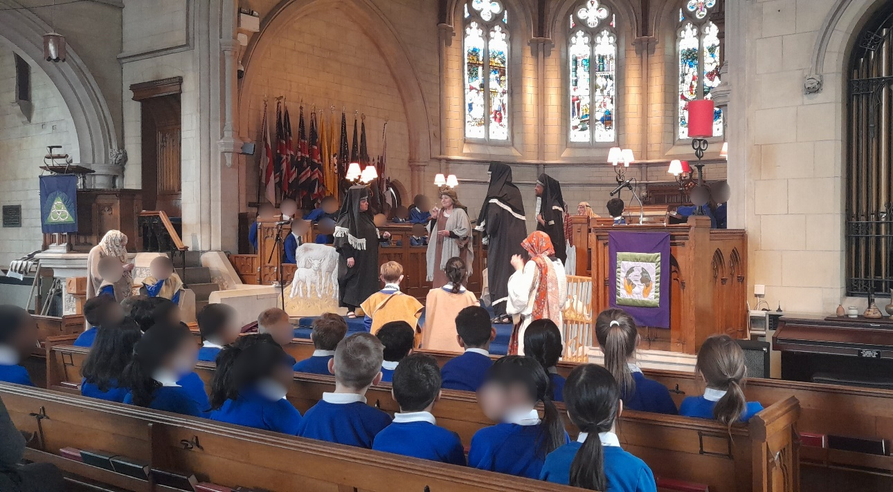



PLEASE PRAY:
- for a new CU at Oaks Park!
- for me (Simon) when coordinating the various groups.
- for GSUS at Cheam High and for dates to be possible.
- for delivery of Self Esteem sessions to year 9 at both Oaks Park and Cheam High, along with a series of CAP money workshops for Year 10 at Cheam High.
- for contact to be established again with Nonsuch to deliver Persecuted Christians.
- Finances to be raised.

Thank you for your continued prayers!

Simon

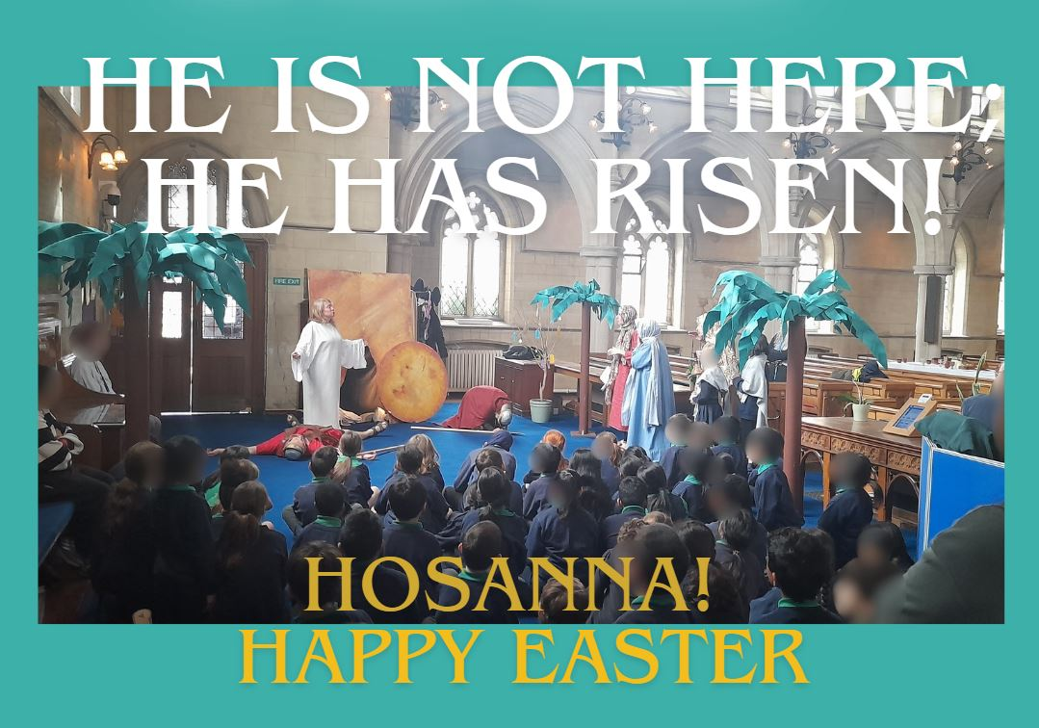







Contact The Team:
Office: St Peter's Church, 193 Bishopsford Road, Carshalton, Morden, SM4 6BH
Email: secretary@suttonschoolswork.co.uk
Tel: 0791 826 8889
Copyright © 2026 Sutton Schoolswork | Charity No: 1052418 | Company Registered Number. 3140690

